File Management Extended Lab Practice
Requirements:
- Students download this document and copy and paste their screen shots in this document. Save the document and then upload your completed document to the assignment in Canvas. Please reach out to Deb Minassian if you are unsure about these instructions.
- Students should be using either Virtual Box or VM Ware and a distribution of Linux other than the Ubuntu VM in the NDG curriculum. Iso files are available for download in Canvas. Students who are unable to use a VM on their personal computer should reach out to Deb Minassian.
The purpose of the extended lab is to provide students with additional practice of skills learned in course. This lab also includes a refresh of commands learned in Linux I. Skill is developed through practice.

Part 1
You are the Linux Administrator for a fast-growing IT company. You have been tasked to create, modify and manage user accounts from the Linux server. The company has hired 12 new employees to fill 4 departments in a new division. The new division includes Software, Hardware, Engineering, and ProdDev. The server must be setup with the appropriate files, folders, users, groups and permissions to ensure proper deployment.
- Create a directory at the root (/) of the file system for the new division. Create a name that reflects the new division. Create the Software, Hardware, Engineering, and ProdDev department directories in the new division directory. Show your screen shot here.
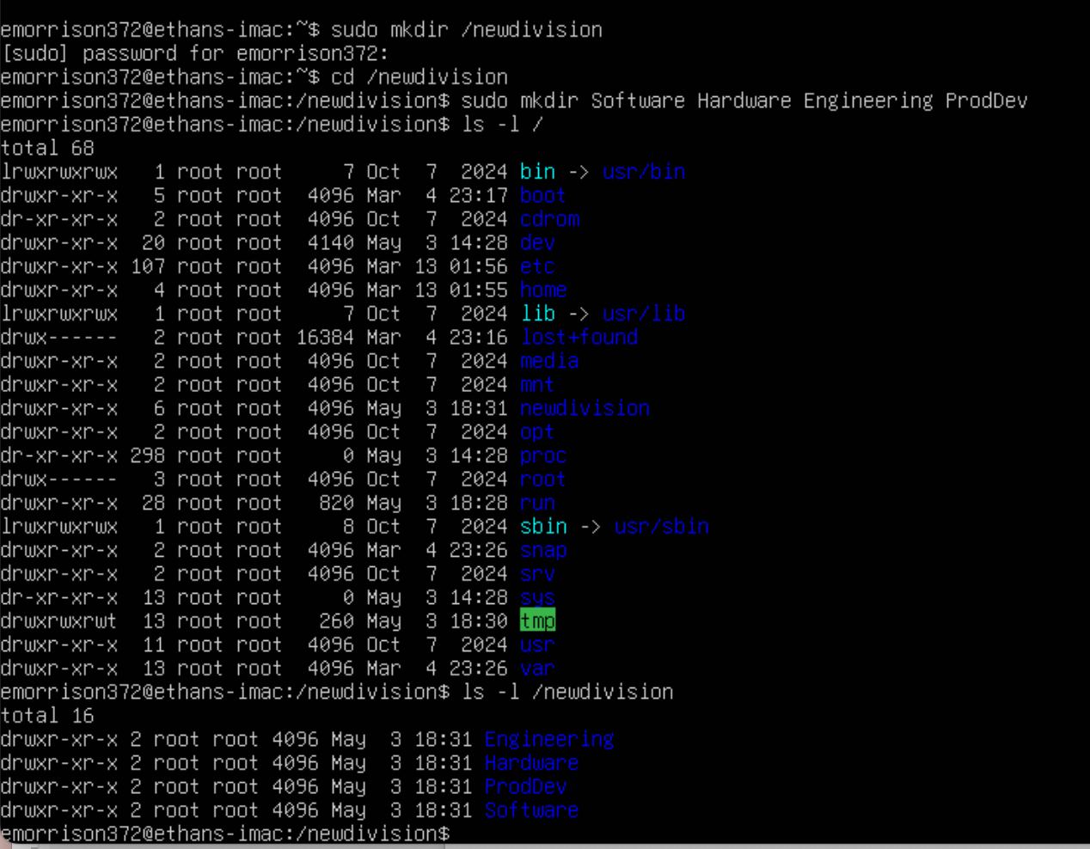

- Create a group for each department. The group name should reflect the department name that the group will be assigned. Show your screen shot here.
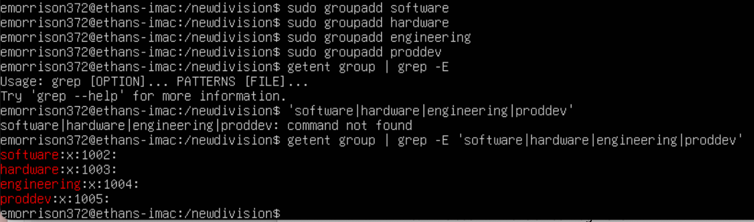

- Create 12 new employee user accounts, assign three users for each department. Show your screen shot here.
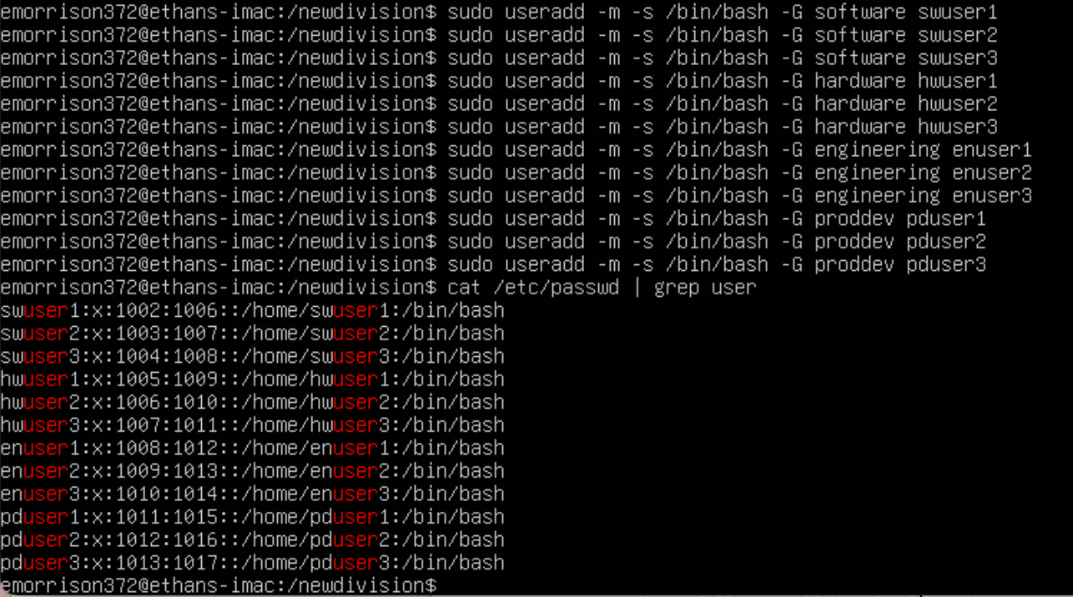

- Create an administrative user for each of the departments.
  - The user will have a Bash login shell
  - The user will belong to the respective group for each department. This will need to be the user’s primary group.
Show your screen shot here.
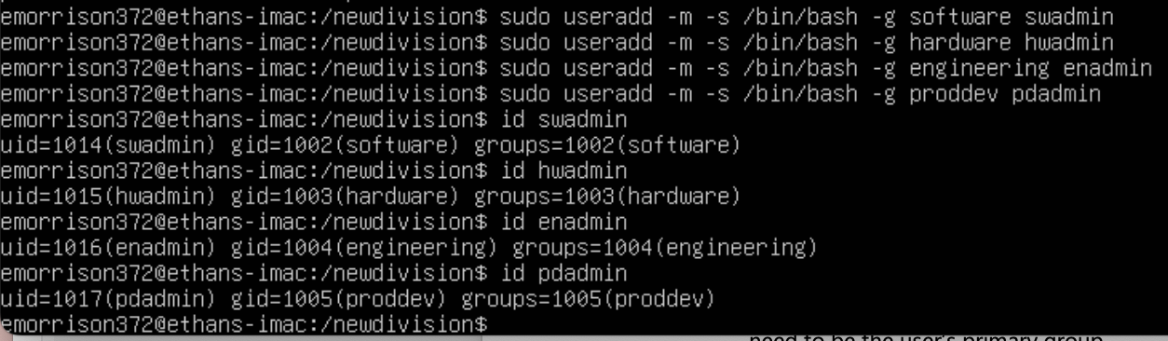

- Implement security with the following modifications:
  - Ensure that the owner of each of the directories is the department administrator and the group ownership is the group for each department.
  - The department administrator will have full access to their respective department directories.
  - Ensure that only the owner of a file in the department’s directory can delete the file. The user will also have ownership of their respective department folders.
  - Normal users in each department will have full access (Read, Write and Execute) to their respective department folders.
  - The department folders will ONLY be accessible by users/administrators in each of the respective departments. Ensure that no one else will have permissions to the folders.
  - Show your screen shot here.
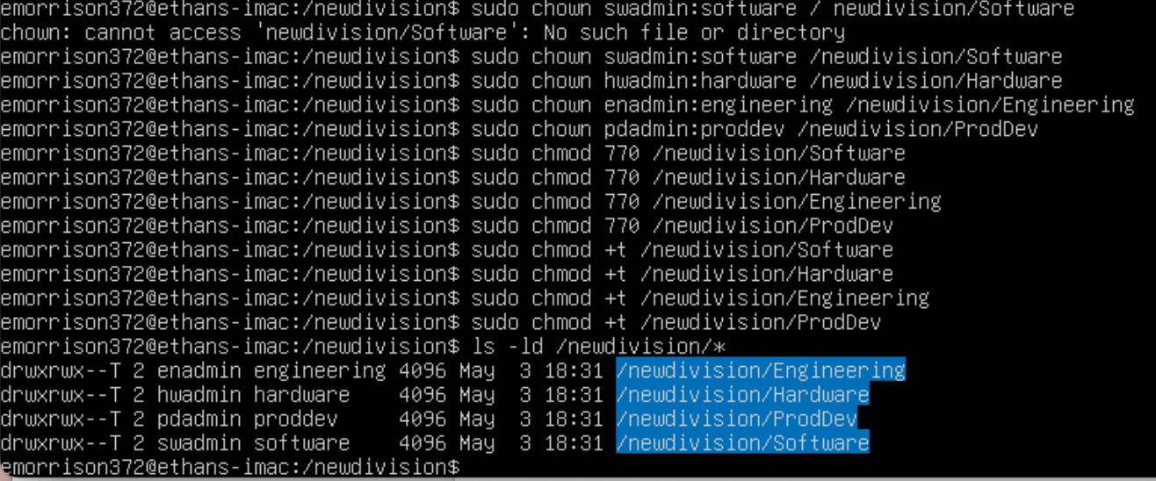

- Create a document in each of the department directories.
  - The ownerships on this file will be the same as the directory it is located in.
  - The document should contain only one line of text that states, “This file contains confidential information for the department.”
  - This file can be read by any user in the department, but can only be modified by the department administrator. No one else has permissions to this file.
Show your screen shot here.
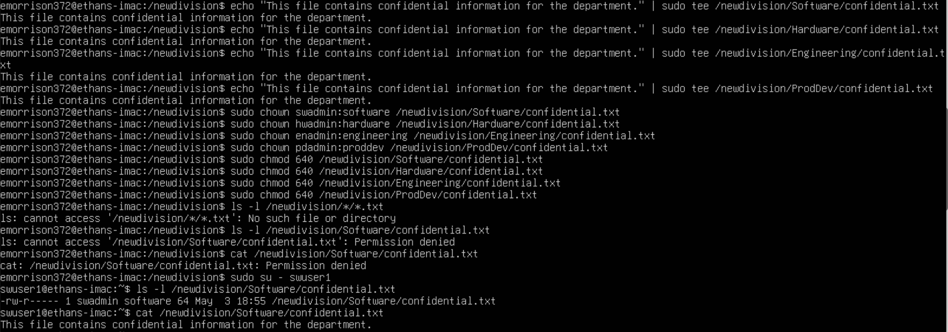

Part 2

Moving around the file system
- Start a terminal. What is your present working directory?
- Change your present working directory to /usr/share/themes
- What is your present working directory now?
- Change your present working directory to the root of the filesystem
- Change your present working directory to /usr/bin/
Show your screen shot here.
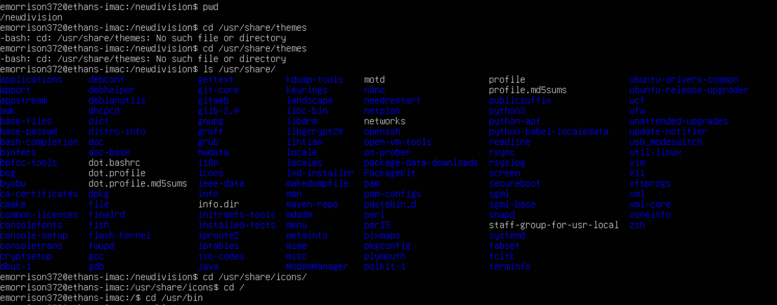
*** I don’t have the “themes” directory, so I went to “icons” instead ***

Part 3

Using pwd and cd with a relative path, clear your terminal window. Change the working directory to YOUR home directory.
- Change the working directory to the Downloads directory.
- Go back 2 directories.
- Where are you now?
- Change the working directory to the Documents/ directory.
Show your screen shot here.
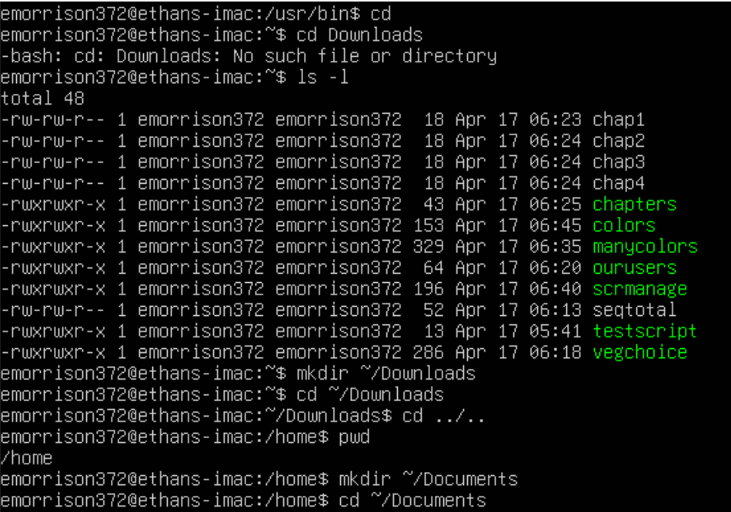
*** I didn’t have the Downloads or Documents directories, so I created them. ***

Part 4
Download this compressed zip file: lab4files.zip from the files located in Canvas. Decompress the zip file in your home directory of your Virtual Machine. Use your Browser to log into Canvas and obtain the lab4files. You will not be able to access these files if you are using the NDG VM.
- Change your present working directory to /usr/share/. Using absolute path, list all the files inside the lab4files directory.
Show your screen shot here.
- Change your present working directory to ~/lab4files. Long list all the files inside your current working directory with human readable file sizes.
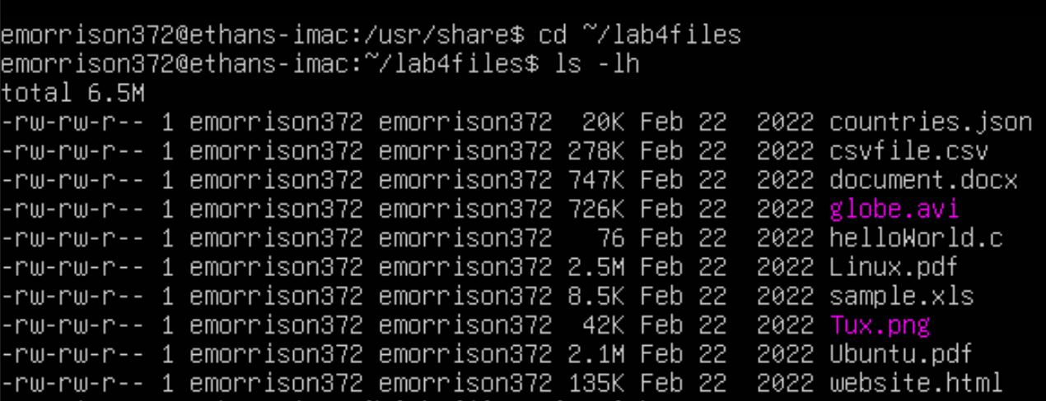
- Long list all the files inside lab4files with human readable file size, and sorted by file size.
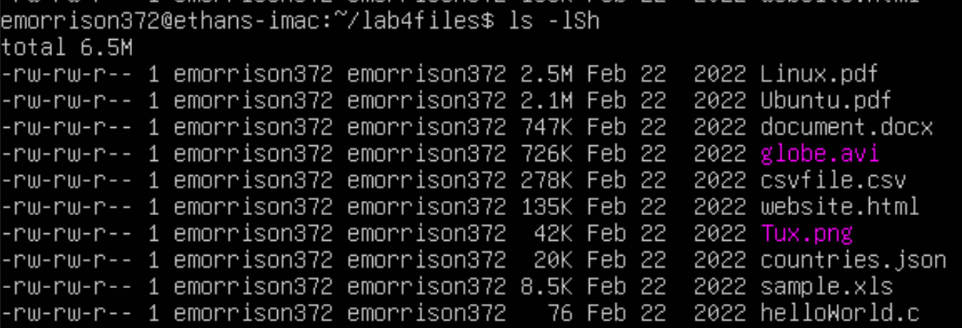
- Long list all the files inside lab4files with human readable file size, sorted by file size, without the user nor the group name, and showing their inode number.
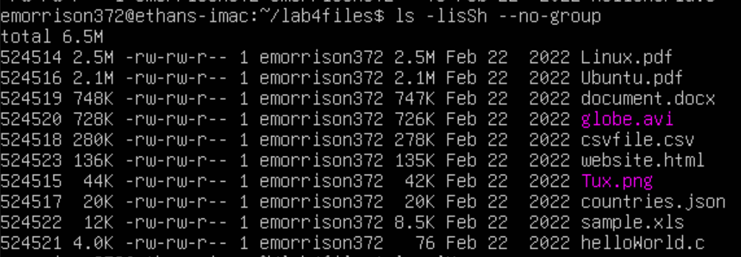
- list all the files inside lab4files sorted by file extension and in reverse order.
Show your screen shot here.
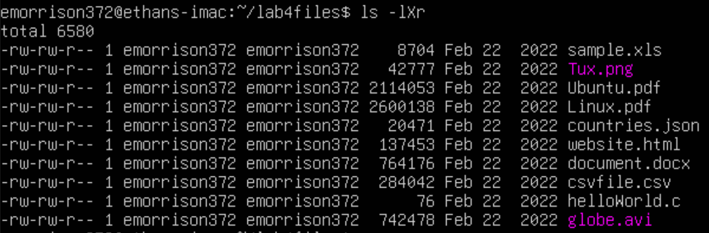

Part 5
You will have to install tree and exa for Part 5. Depending on which version of Linux you are running in your VM will depend on the commands you will use to install these applications. Please provide the screen shot of your installation here.

- Using absolute path and having /etc as your present working directory. Display a tree of the directory lab4files.
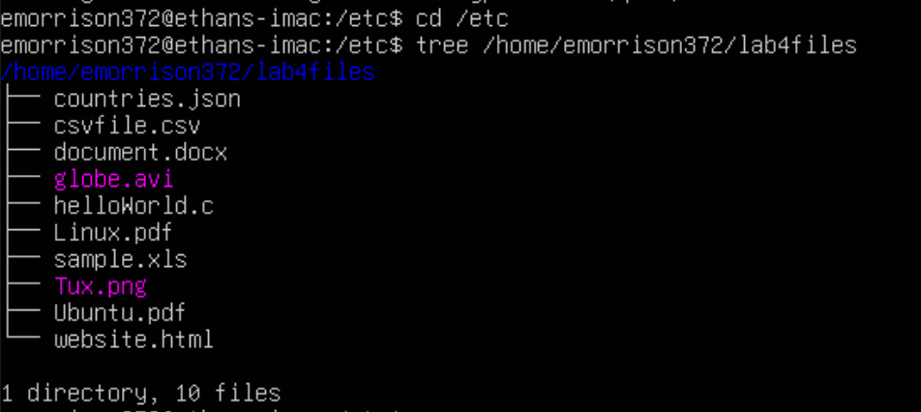
- Change your present working directory to your Downloads directory. Display a tree of the directory lab4files with the full path prefix for each file, the file permissions, and the file size in human readable format.
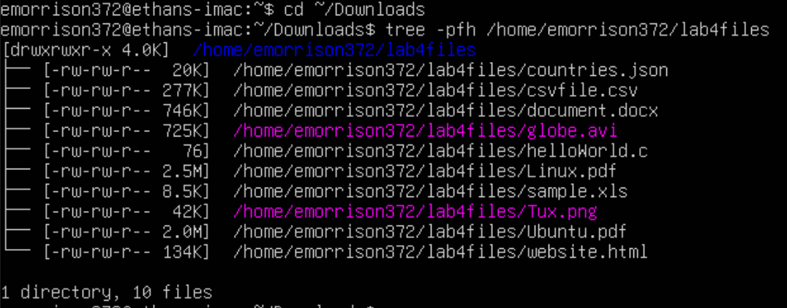
- Display a tree of the directory lab4files sorted by last modified time and showing the file owner and group.
Show your screen shot here.
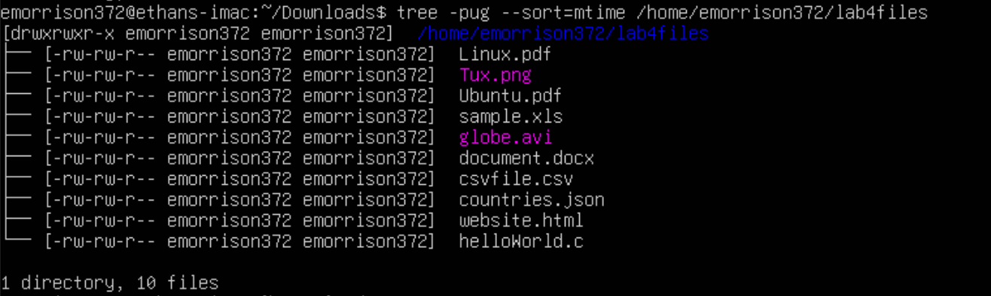

- Once you have installed exa, list all the options of the exa command.
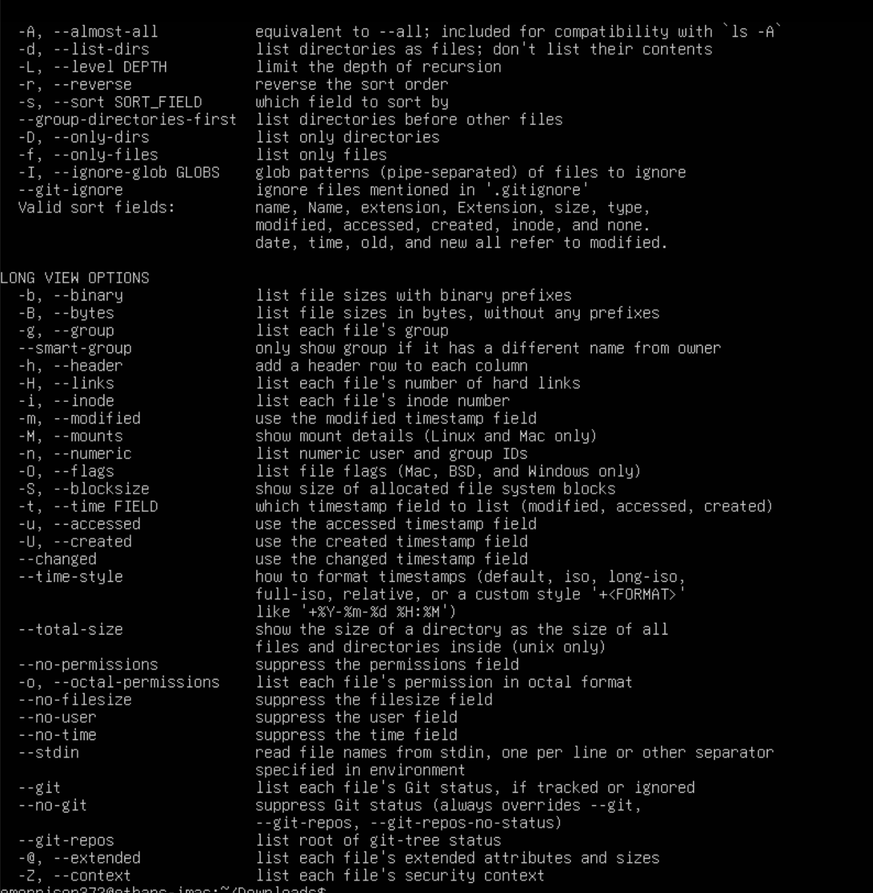
- Using exa, long list all the files inside lab4files
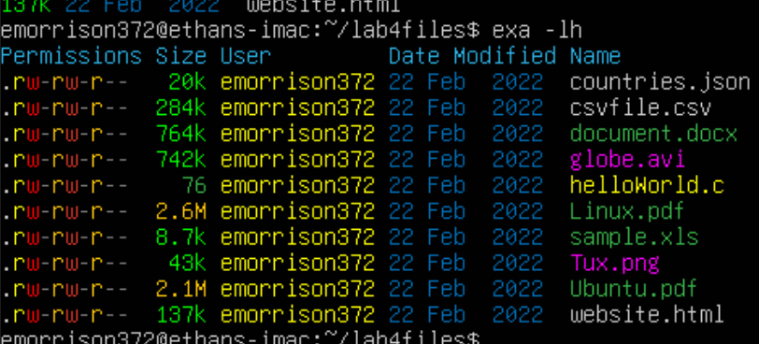
- Long list lab4files showing the header that indicates what each column means.
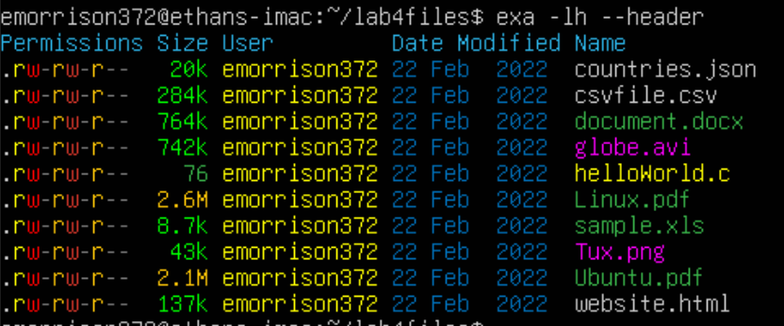
- Long list lab4files without the file owner nor group including the header and the date the file was created.
- Show your screen shot here.
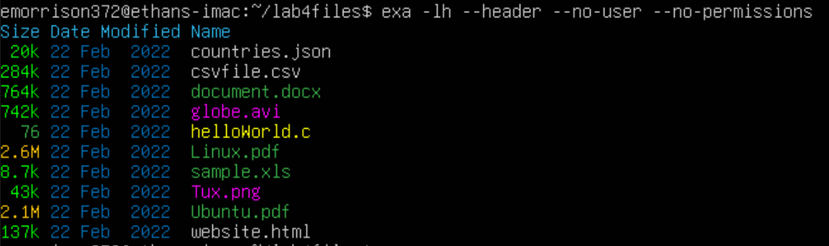

Part 6
Use this image as a visual aid during this question
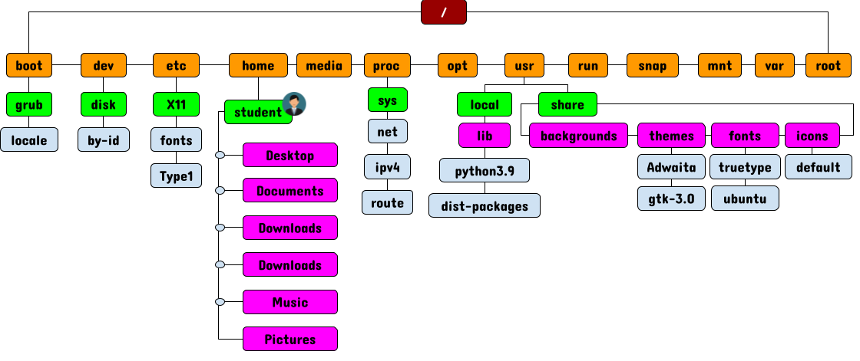
- Open a new terminal. What is your present/current working directory?
- Change your present/current working directory to the default directory located inside /usr
- Change your present/current working directory to the ipv4 directory located inside /proc
- change your present/current working directory to the previous present/working directory.
- List all the files inside share/backgrounds without changing your present working directory.
- List all the files inside your lab4files directory located in YOUR home directory.
- List all the files inside your Downloads directory. Your present working directory has to be /home before your can list all the files.
- Change your present/current working directory to disk/by-id and from there long list all the files in your home directory including hidden files.
- List all the files sorted by modification time inside the share/themes directory.
- List all the files sorted by file extension inside the /usr/share directory.
Show your screen shot here.
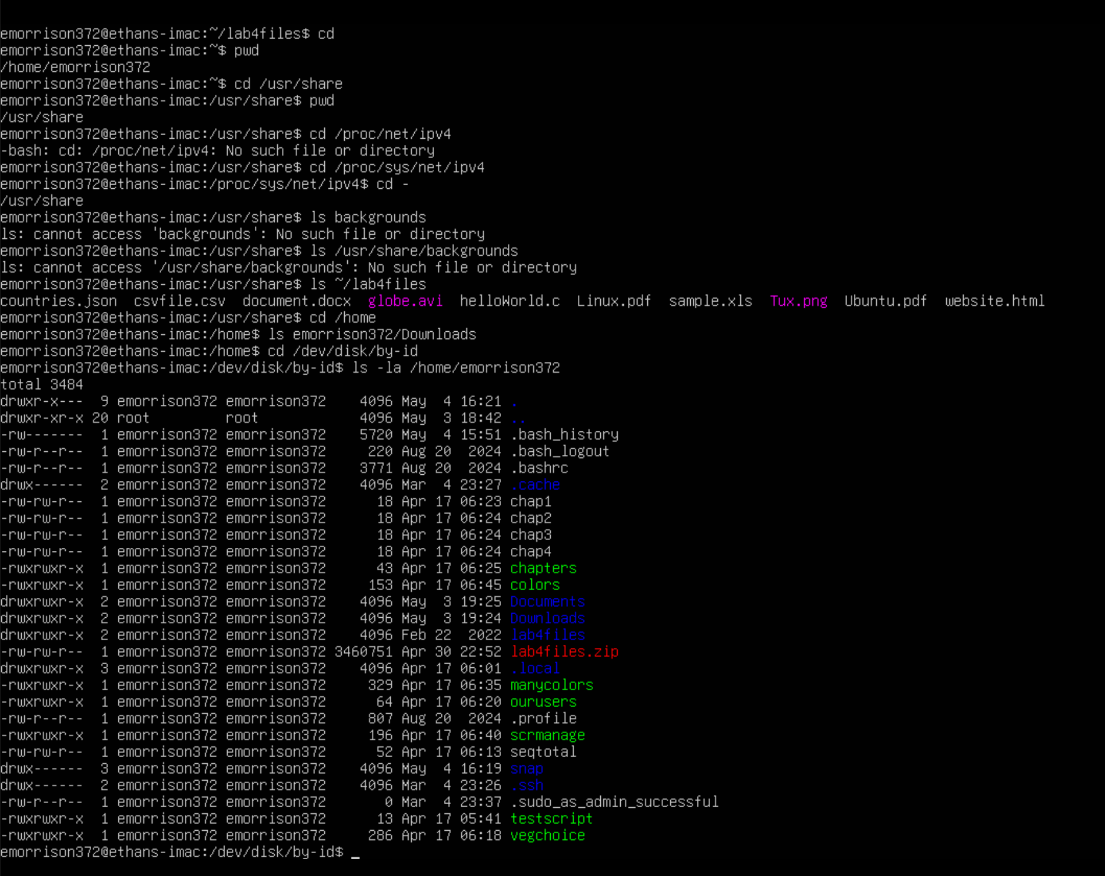
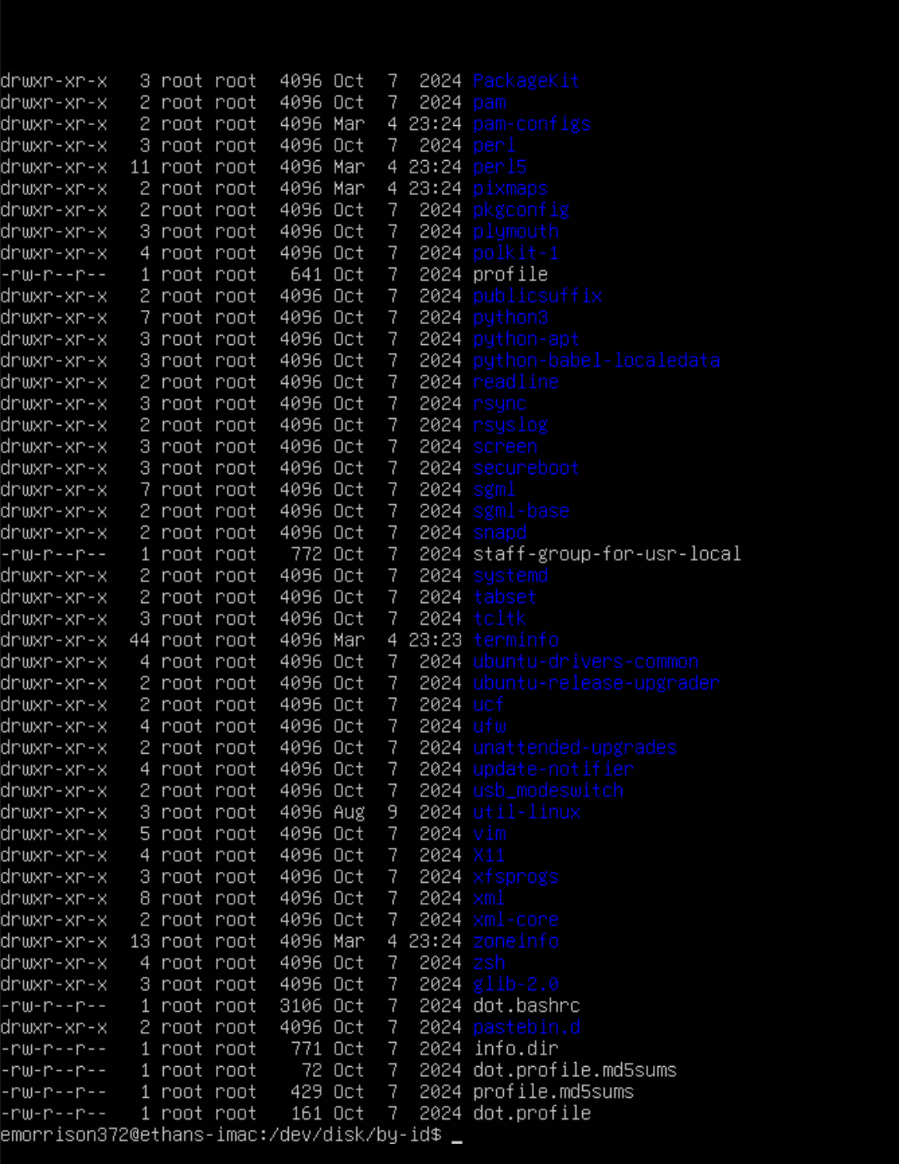

Part 7
- Create a Directory in YOUR home directory labeled: Part7.
- Change your current working directory to ~/Part7.
- Create 3 directories: pets,docs,songs. Inside each directory, create 2 subdirectories called: new and old.
- Inside the new and old directories, create 3 files: file1, file2, and file3.
- Use the tree command to list the Part7 directory.
Show your screen shot here.
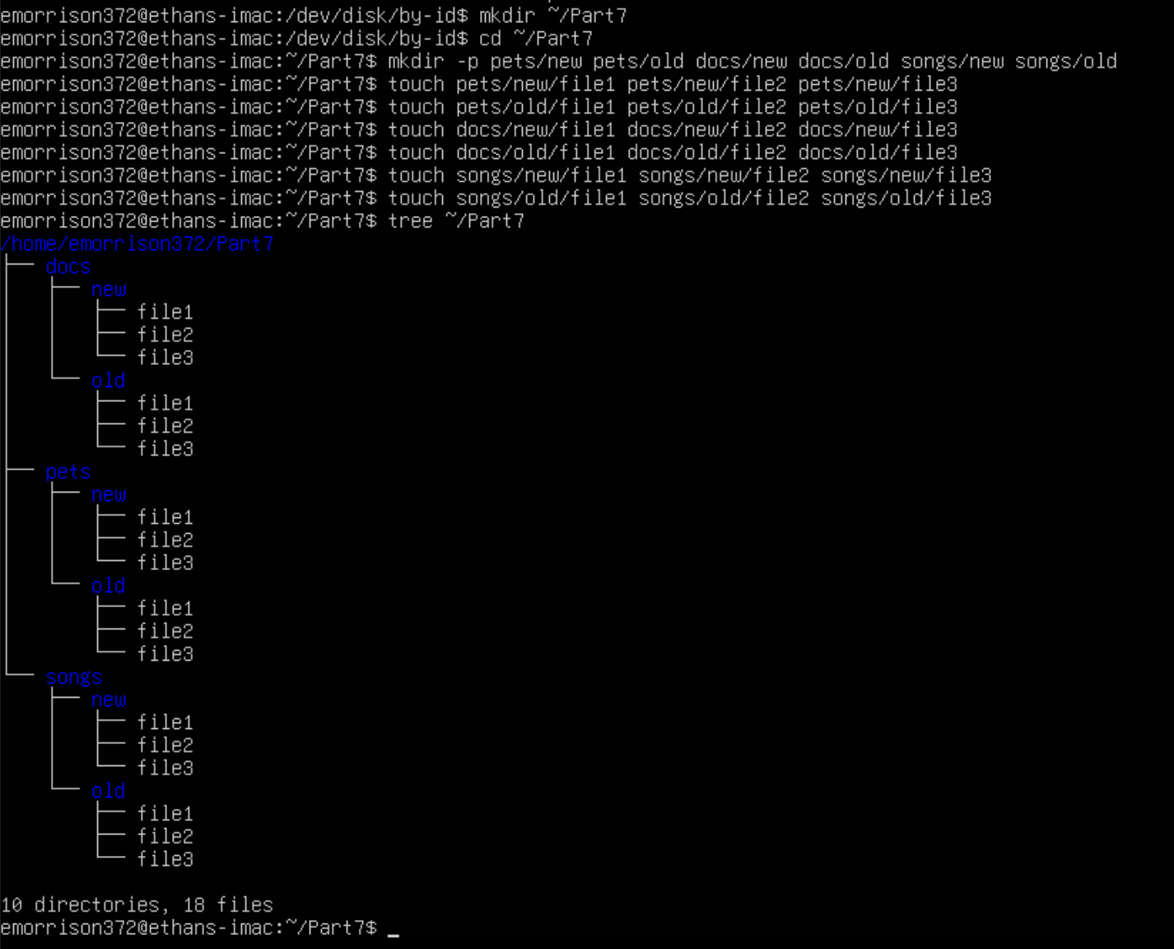

Part 8
- Change your current working directory to: /srv/
- Remove the file1, file2, file3 files inside the labs/pets/new/ directory without changing your current working directory.
- Remove the pets directory without changing your current working directory.
- Remove the docs and songs directories without changing your current working directory.
- Remove the Part7 directory without changing your current working directory.
Show your screen shot here.
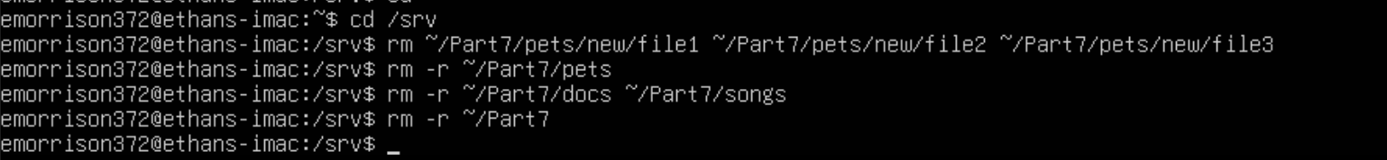

Part 9
Include your experiences and answers to all the underlying parts in your report.

I spent 3 hours and 0 minutes to finish this hands-on lab.

I have completed 100% (percent) of this lab. I expect a grade of A (A, B, C, D or F) on this lab.

This lab helped me refresh users and groups, and practice file management commands using real-world examples. Choose a number to indicate how much this lab helped you.

1 2 3 4 5
(less helpful) (more helpful)

*Submit your script to the Assignment Portal

Thank you!

